Performance-based financing and a public-private partnership pilot for universal health coverage
  - Cameroon

This exemplar examines Cameroon’s attempt to move toward universal health coverage through a public-private partnership pilot built on a longer performance-based financing experience. It considers both the promise of that approach and the constraints created by the absence of a full legal and fiscal framework.
Core exemplar
UHC Phase 1 pilot via public-private partnership (PPP) and Performance-Based Financing (PBF).
Why it matters for ALM: It shows how a country can combine output-based financing and private implementation support to move from pilots toward a broader UHC architecture.
Primary ALM contribution: More health for the money, governance and accountability, and equity through targeted service coverage.
Replicability potential: Moderate, especially for countries using PBF as a stepping stone while testing PPP-based service delivery models.

1. Context: High Out-of-Pocket Spending and Performance-Based Financing Reform
Cameroon’s health system is marked by very high out-of-pocket spending, low public financing, and a long search for workable reform instruments. Private spending accounted for 71.8% of total health financing in 2022, while government health expenditure stood at only 3.9% of GDP and per-capita spending was about USD 58. Since 2011, the country’s main financing innovation has been performance-based financing, first piloted in Littoral and later expanded through the SPARK-Health project. That experience created some of the operational foundations for later UHC efforts, but it did not close the larger financing gap.
Cameroon’s UHC effort goes back to a 2017 presidential declaration, but it only moved into implementation territory in 2020 when Société Santé Universelle Cameroun (SUCAM), a private contractor, was selected to manage delivery. After several delays, Phase 1 was formally launched on 12 April 2023 in the Mandjou health district of Bertoua in the East Region.

2. Mechanism: Performance-Based Financing and a UHC Public-Private Partnership
Cameroon's approach combines three instruments:
- PBF National Scale-Up: Under SPARK-Health, PBF was integrated into the national system across all districts, incentivizing facilities based on service-delivery outputs adjusted for quality. Early independent evaluations found promising results on facility-level accountability and service availability.
- Chèque Santé: A voucher system for pregnant women enabling access to obstetric care at contracted facilities — a targeted demand-side financing mechanism. Supported by GIZ's P4H and PROPOSAR projects in the Southern and Eastern regions.
- UHC Phase 1 via PPP: The SUCAM PPP contract to manage UHC implementation in the East Region is unique on the continent. Phase 1 targets 6 million beneficiaries — pregnant women, children under five (free malaria treatment), people living with HIV/AIDS, tuberculosis patients, onchocerciasis patients, and kidney-failure patients on dialysis.
Financing for the pilot is backed by a Ministry of Public Health and Ministry of Finance disbursement arrangement covering 12.8 billion CFA francs, of which 11 billion CFA had already been disbursed, alongside weekly Treasury transfers. A formal information-sharing mechanism between Treasury and health-financing units has also been set up to improve control and execution.
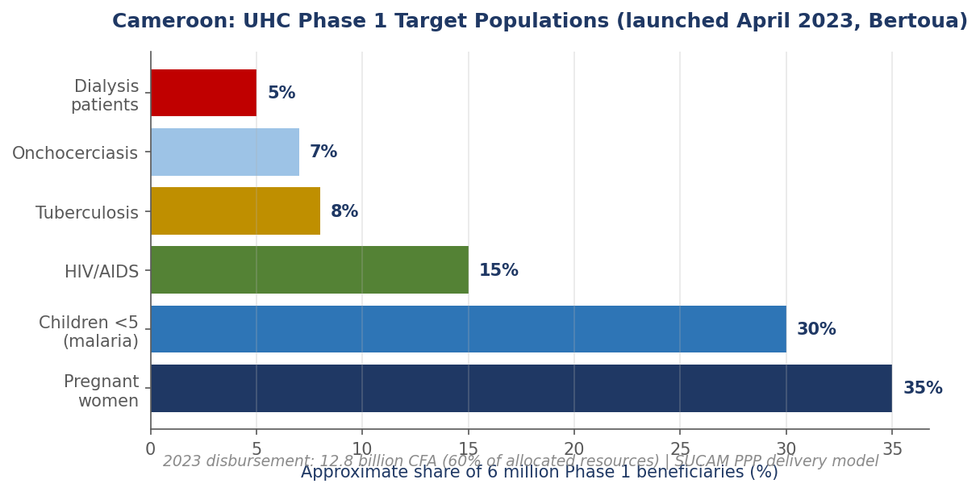
Figure C-1. Cameroon: UHC Phase 1 Target Populations (launched April 2023, Bertoua). The SUCAM PPP delivers care to 6 million beneficiaries across six priority groups: pregnant women, children under five, and patients with HIV/AIDS, TB, onchocerciasis, and dialysis needs.

3. Outcomes: UHC Pilot Rollout and Expanded Service Delivery
Since April 2023 launch, UHC Phase 1 has enrolled initial beneficiaries at six regional enrolment posts, with a Souza-based 2024 study examining enrolment patterns (finding education and information about UHC as key determinants of enrolment). By end of first year of implementation, more than 7,000 online registrations had been completed and enrolment campaigns were active in the East region. PBF has led to greater availability of medical supplies, increased provider financial autonomy, and enhanced information systems. In 2024 the second-year evaluation identified training-content harmonization, pooled enrolment materials, and information-sharing improvements with the Ministry of Social Affairs and Ministry of Social Security as key reforms to accelerate enrolment.
As of 2025, however, no formal UHC Bill had been deliberated or passed by the National Assembly, and no comprehensive feasibility study had been published. Cameroon participated in the WHO African Region's 2024 survey on health financing reforms and is among countries planning to scale PBF and develop a broader contributory UHC scheme.
Key Vulnerability
- What is at risk: Scaling Cameroon’s UHC model beyond a pilot—because the enabling legal and fiscal foundations are not yet in place.
- Why it matters (evidence): The SUCAM PPP is innovative but still untested at national scale. No enabling UHC legislation has been passed by the National Assembly, leaving implementation in a regulatory grey zone. Cash-flow pressure at the Public Treasury and weak Ministry of Finance–Ministry of Health collaboration remain structural barriers. PBF sustainability is also uncertain: SPARK-Health’s 2019–2025 financing window closed in 2025 with follow-on funding not guaranteed. Civil society has raised governance and transparency concerns about the SUCAM contract. Meanwhile, health financing pressures remain severe: health spending is 3.9% of GDP and out-of-pocket spending is 71.8%.
- What would reduce the risk: Passage of a UHC law, clearer governance and transparency provisions for the PPP, and a credible domestic-financing plan that reduces reliance on time-bound external financing while improving Treasury–MOH execution discipline.

4. Cameroon on the ALM Scorecard
Cameroon’s scorecard shows an ambitious but unfinished reform trajectory, with two commitments rated On Track, seven rated Partial, and one rated Off Track. The two On Track ratings reflect meaningful progress in partner leverage and private-sector engagement, particularly through SPARK-Health and the SUCAM PPP. The seven Partial ratings capture the fact that many important reform elements are present but not yet secured through law, broad-scale implementation, or stable financing. The Off Track rating on domestic resource mobilization reflects persistently low public spending and very high out-of-pocket costs. Overall, the scorecard is consistent with a country piloting promising reform instruments without yet having the legal and fiscal base needed for full-scale UHC implementation.
ALM Scorecard Heat-Map
Country | Cameroon
1. Political Agenda
2. Leverage Partners
3. Domestic Mobilization
4. Private Sector
5. PMPA Harmonization
6. Operational Undertakings
7. Monitoring & Reporting
8. Accountability Framework
9. Hosting Role
10. Leveraging AU Support
Green = On Track, Amber = Partial, Red = Off Track

5. Key Lessons and Policy Implications
- PPP as UHC delivery model. Cameroon's SUCAM contract is the boldest service-delivery PPP in African UHC financing. Its success or failure will shape the continental PPP debate. Early signals on enrolment uptake and governance are mixed, reinforcing that PPPs require robust regulatory frameworks as prerequisite (Egypt's three-authority model being the reference).
- PBF as stepping stone. Cameroon's 14-year PBF trajectory demonstrates that PBF alone is not a path to UHC but can serve as a stepping stone — improving facility-level accountability, information systems, and provider autonomy that are preconditions for an insurance-based financing architecture.
- Voucher systems as targeted equity tool. Chèque Santé's targeting of pregnant women for free obstetric care is a replicable demand-side intervention, particularly in contexts where full insurance coverage is fiscally infeasible in the short term.
- The main missing piece in Cameroon is still the legal framework. Without it, the PPP remains exposed, PBF sustainability is uncertain, and the 2017 political commitment lacks full institutional backing.
- Treasury–MOH coordination. Cameroon's 30-day Financial Control commitment time (vs several months previously) and the 500 million CFA weekly Treasury disbursement are concrete public-financial-management wins. The information-sharing framework between Treasury Committee, DRFP, and Specialized Paymaster is a replicable mechanism for ALM Commitment 6(vi) biennial Minister-level coordination.

Editors: Caroline Kwamboka, Matthias Brucker
Author: Chris Alando
© African Renaissance Trust, 2026.

Key words: More health for the money, governance and accountability, Equity and financial protection, Universal health insurance, public-private-partnership, performance-based financing, Cameroon, Central Africa

References
World Health Organization. (2025, December). Global Health Expenditure Database. https://apps.who.int/nha/database
UNAIDS. (2025). AIDSinfo: Global data on HIV epidemiology and response. https://aidsinfo.unaids.org
World Bank. (2025). World Development Indicators. https://databank.worldbank.org/source/world-development-indicators
AUDA-NEPAD. (2024). Africa Scorecard on Domestic Financing for Health. https://africascorecard.nepad.org
République du Cameroun. Démarrage de la Couverture Santé Universelle (CSU) Phase 1 — Inauguration à Bertoua, 12 avril 2023 [Communiqué]. Yaoundé: Ministère de la Santé Publique; 2023 . https://www.minsante.cm/csu-phase-1
World Bank. Cameroon Health System Performance Strengthening Project (SPARK-Health, P156679). Washington, DC: World Bank Group; 2019–2025. https://projects.worldbank.org/en/projects-operations/project-detail/P156679
WHO Regional Office for Africa. 2024 Regional Survey on Health Financing Reforms — Cameroon country profile [Internet]. Brazzaville: WHO AFRO; 2024 . https://www.afro.who.int/publications/2024-health-financing-survey

ALM score card sources: Cameroon (2/10 On Track, 7 Partial, 1 Off Track)
C1: Political agenda — Partial Indicators: UHC Phase 1 launched Apr 2023 SUCAM PPP Bertoua; no UHC bill Sources: UHC Phase 1 launch (minsante.cm/csu-phase-1); MoH Cameroon
C2: Leverage partners — On Track Indicators: WB SPARK-Health $220M (2019-2025); WHO, ILO, USAID, GIZ, French/German bilateral Sources: WB SPARK-Health P156679 (projects.worldbank.org); WHO Cameroon
C3: Domestic mobilisation — Off Track Indicators: Health 3.9% GDP; OOP 71.8%; ~$58 per capita; no earmarked taxes; no NHI legislation Sources: WHO GHED; WB Cameroon PER; WHO AFRO 2024 HF Survey
C4: Private sector — On Track Indicators: SUCAM PPP = boldest service-delivery PPP on continent; mission hospitals significant Sources: SUCAM PPP documentation; MoH PPP framework
C5: PMPA — Partial Indicators: DPM regulator; limited local pharma; CEMAC harmonisation; OCEAC coordination Sources: DPM Cameroon; CEMAC Regional Health; OCEAC
C6: Operational — Partial Indicators: UHC Phase 1 SUCAM PPP; PBF pilots sustainability tied to external financing; no insurance Sources: Cameroon PBF documentation; SPARK-Health reports
C7: Monitoring — Partial Indicators: DHIS2 partial; NHA periodic; WHO Regional Survey participant; sub-national data quality varies Sources: Cameroon DHIS2; WHO Cameroon; INS health data
C8: Accountability — Partial Indicators: Limited parliamentary oversight; civil society growing; Cour des Comptes; SPARK-Health monitoring external Sources: Cour des Comptes audits; SPARK-Health documentation
C9: Hosting role — Partial Indicators: CEMAC HQ; OCEAC in Yaoundé; not major ALM convener Sources: CEMAC Secretariat; OCEAC Yaoundé
C10: Leveraging AU — Partial Indicators: CEMAC+ECCAS integration; AU PAVM participation; limited AVMA engagement Sources: ECCAS Regional Health; AU PAVM; AUDA-NEPAD

